Institute of Computer Technology

B. Tech Computer Science and Engineering

Subject: DS (2CSE302)

**PRACTICAL-20**

**AIM: - Implement bubble sort and insertion sort.**

**1. Swati is working on different sorting methods to sort the data. She wants to prepare sorting calculator which provides the facilities to sort all kind of sorting methods for same data. Kindly refer given scenario for calculator and implement it in C:**

**How many number you want to sort:**

**8**

**Enter the Elements for Sorting:**

**34**

**22**

**56**

**13**

**89**

**5**

**67**

**45**

**List of sorting methods:**

**1. Bubble Sort**

**2. Insertion Sort**

**3. Exit**

**Which choice do you want apply?**

**1**

**Pass-1: 22 34 13 56 5 67 45 89**

**Pass-2: 22 13 34 5 56 45 67 89**

**Pass-3: 13 22 5 34 45 56 67 89**

**Pass-4: 13 5 22 34 45 56 67 89**

**Pass-5: 5 13 22 34 45 56 67 89**

**Pass-6: 5 13 22 34 45 56 67 89**

**Pass-7: 5 13 22 34 45 56 67 89**

***SOLUTION***

#include <stdio.h>

#include <stdlib.h>

void PrintArr(int arr[], int n)

{

for (int i = 0; i < n; i++)

{

printf("%d ", arr[i]);

}

}

void BubbleSort(int arr[], int n)

{

int yash;

for (int i = 0; i < n-1; i++)

{

for (int j = 0; j < n - i - 1; j++)

{

if (arr[j] > arr[j + 1])

{

yash = arr[j];

arr[j] = arr[j + 1];

arr[j + 1] = yash;

}

}

printf("\nPass %d : ", i+1);

PrintArr(arr, n);

}

}

void InsertionSort(int arr[], int n)

{

int i, yash, j;

for (i = 1; i < n; i++)

{

yash = arr[i];

j = i - 1;

while (j >= 0 && arr[j] > yash)

{

arr[j + 1] = arr[j];

j = j - 1;

}

arr[j + 1] = yash;

printf("\nPass %d : ", i);

PrintArr(arr, n);

}

}

int main()

{

int arr[20];

int num, ch;

printf("\nHow many number you want to sort: ");

scanf("%d", &num);

printf("\nEnter the Elements for Sorting: ");

for (int i = 0; i < num; i++)

{

scanf("%d", &arr[i]);

}

printf("\n\nList of Sorting methods:\n1. Bubble Sort\n2. Insertion Sort\n3. Exit\n\nWhich choice do you want to apply? ");

scanf("%d", &ch);

switch (ch)

{

case 1:

printf("\nBefore Bubble Sort : ");

PrintArr(arr, num);

printf("\n");

BubbleSort(arr, num);

printf("\n\nAfter Bubble Sort : ");

PrintArr(arr, num);

printf("\n");

break;

case 2:

printf("\nBefore Insertion Sort : ");

PrintArr(arr, num);

printf("\n");

InsertionSort(arr, num);

printf("\n\nAfter Insertion Sort : ");

PrintArr(arr, num);

printf("\n");

break;

case 3:

exit(0);

break;

default:

break;

}

printf("\n");

return 0;

}

***OUTPUT***

**Bubble Sort: -**

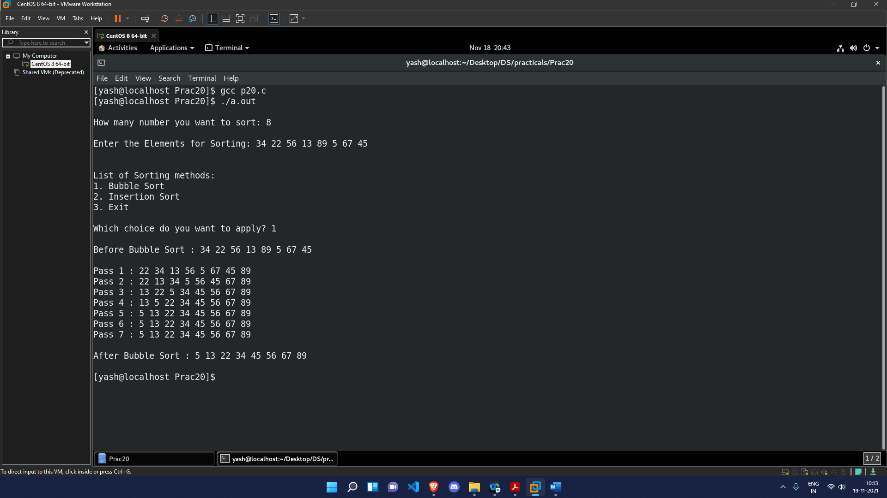

**Insertion Sort: -**

